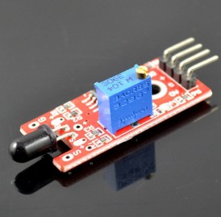
This project will use a flame sensor to detect fire. When fire flame is detected, LED in the circuit will turn on.
Step 1: Connect fire sensor to Arduino as per following graph:
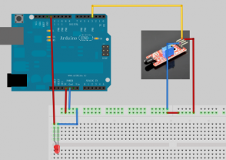
Step 2: Download sample code, and load it into Arduino IDE.
Step 3: Run the code and you will see result same as following video.

